Final for Math 361
Quantitative Methods for Fixed-Income Securities
May 24, 2005

Solution:
1.
1.1 The risk-neutralized interest-rate tree is
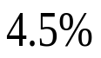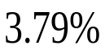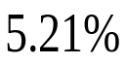
1-p
p
where 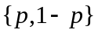 are the risk-neutral probabilities. The corresponding price tree is
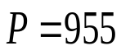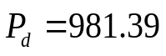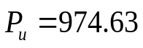
1-p
p
which satisfy
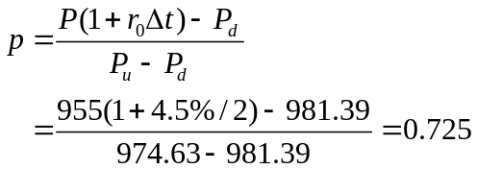
1.2 The option tree and the price are
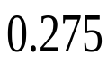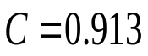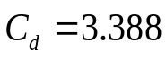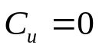
p
1.3 Buy
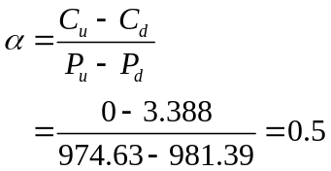
unit of the 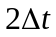- maturity zero-coupon bond, and ``buy”
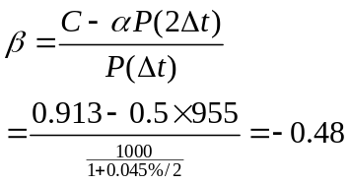
The negative sign means to short.
- By considering the following interest-rate tree in p.252,
0.5
0.5
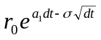
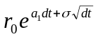
Since 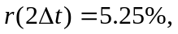we have
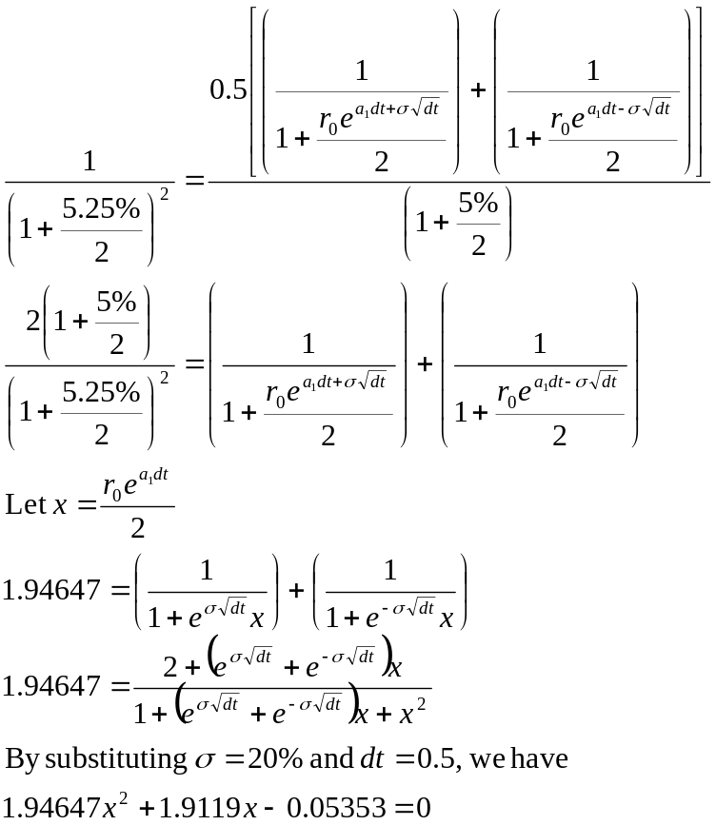
So, x = 0.027243 or x = - 1.00948 (rejected).
Therefore,  = 0.1718.
The resulting 1-period interest-rate tree is given by
5%
4.7300%
6.2762%
0.5
0.5
- By referring to the 2-period interest rate tree in p.252 and taking 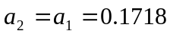, we have
0.5
7.8781%
0.5
0.5
0.5
4.7300%
6.2762%
0.5
0.5
5%
5.9372%
4.4745%
On date1, the state 1 and state 0 payoffs are, respectively,
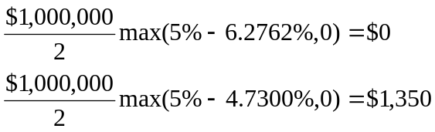
Similarly on date 2, the state 2, 1, and 0 payoffs are, respectively,
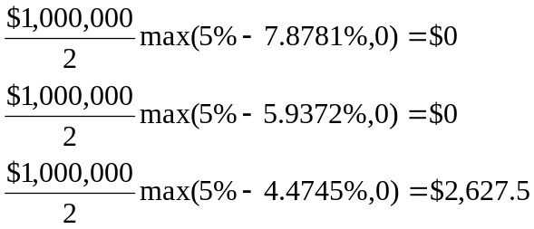
The resulting date 1 values in states 1 and 0, respectively, are
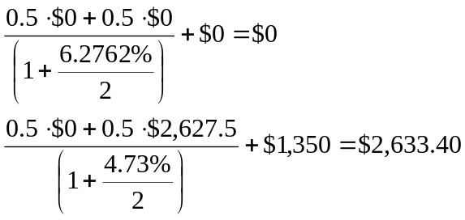
Finally, the price of an interest-rate floor on date 0 is
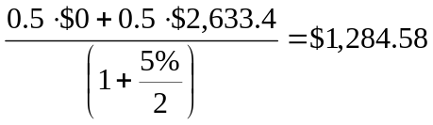

4. For this bond,
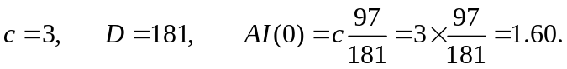
4.5 The P&L is
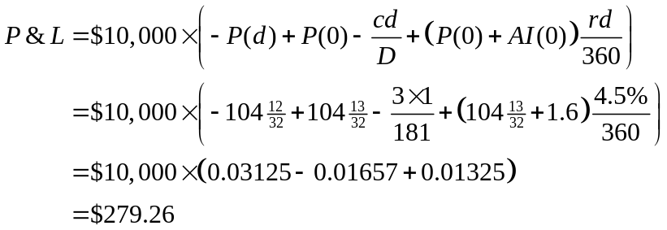
4.6 The cost of carry is
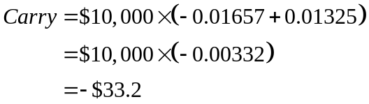
4.7 The breakeven price is the price that makes 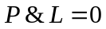. So it is
